

**Fear, Unemployment and Migration**

Speech given by

David Blanchflower, Bruce V. Rauner Professor, Dartmouth College, University of Stirling, IZA, CESifo, NBER and Member, Monetary Policy Committee, Bank of England

At the Esmée Fairbairn Memorial Lecture, Lancaster University 30 October 2007

I am most grateful to Roger Kelly, Nicola Scott and Chris Shadforth for their invaluable assistance.

1

All speeches are available online at [www.bankofengland.co.uk/publications/Pages/speeches/default.aspx](http://www.bankofengland.co.uk/publications/Pages/speeches/default.aspx)

I am delighted to be able to make this speech in support of so worthy a cause as the Esmée Fairbairn foundation, one of the largest independent grant making foundations in the UK. The Esmée Fairbairn Foundation provides grants to organisations which aim to improve the quality for life for people and communities in the UK, and the foundation's work is particularly important in that it often considers work that others find hard to fund, either because it breaks new ground, appears too risky, requires core funding or needs a more unusual form of financial help such as a loan.

I have to admit (and this may not come as a surprise to those who know my background as a labour economist) that I am particularly interested in the work the Esmée Fairbairn Foundation does in promoting enterprise and independence. At a microeconomic level, supply-side initiatives to help people to help themselves provides a sure-fire route out of poverty and social exclusion. At a macroeconomic level, such initiatives produce positive labour market outcomes by making the workforce more flexible and increasing skills, thereby increasing the efficiency of the labour market, and boosting economic growth.

One sector of society that has traditionally suffered from social exclusion is immigrants - indeed this is sometimes seen as a reason why the rate of self employment tends to be higher among immigrants than the indigenous population. For today's talk I am going to look at a specific group of recent arrivals - namely workers from the EU Accession Countries - and consider their impact on the UK labour market and on the wider economy.

Migration has been one of the key areas of economic debate in the UK over the past few years. We have all been exposed to stories of Eastern European migrants moving en masse to the UK, ready to work longer hours and for less money than Britons. And there is some truth to these stories. But I believe these flows have been very good for the UK economy, not bad as some would have us believe.

As a backdrop to this discussion, I’d like to briefly characterise what has been happening to the UK labour market over the last couple of years or so. This has heavily influenced my voting behaviour on the MPC, and given rise to my reputation for being a ‘dove’, because I believe that there is considerably more slack in the labour market at present than is popularly held to be the case.

1. Unemployment has risen since 2005, but has slowed only a little in 2007.
2. The inactivity rate fell when unemployment was rising but has recently increased alongside the fall in unemployment. This increasingly looks like a discouraged worker effect where workers withdraw from the labour force in recessions when they can't find jobs.
3. There have been very few employee jobs created. Indeed over the last 12 months the number fell by 1000.
4. There have been strong increases in temporary workers who can’t find permanent jobs and part-timers who can’t find full-time jobs.
5. The number of self-employed has grown at a rate that has never been seen in the past and is clearly unsustainable in the future. One need only compare the data for the UK to that of the EU and the US to see the significance of this change. In a recent paper (Blanchflower and Shadforth 2007a) I argued that at least half of that increase had to do with rising house prices freeing up capital constraints.
6. Even though there has apparently been strength on the demand side based on reports from business pricing surveys, wage growth has been muted. I have been arguing that this is the dog that hasn’t and will not bark for some time now. This can be seen from the series on average earnings (chart 1) and on wage settlements (chart 2). The fact that wages have been flat remains a puzzle principally to those who believe demand is booming and the labour market is tight.

To what extent have these changes been driven by these 'so-called' migrants? I use the term ‘so-called’ because many of these individuals have no intention of living or moving abroad for any more than a few months at a time – they are more akin to *guest workers*. While by 2007, approximately 700,000 had come to the UK since 2004, the data shown in table 1 suggest that as many as half of that number have actually returned home, perhaps moving back and forth several times. And the intentions of the latest waves of workers appear to support this trend; 55% of workers arriving in 2007Q1 anticipated staying less than 3 months. This ebb and flow of workers reflects what some would call the ‘globalisation’ of labour markets – the pool of individuals from which UK firms can pull workers increased over-night on May 1st 2004, the date on which the EU expanded to 25 nations.

So who has come? Table 2 helps us characterise the flows of people from the A8 as follows:

1. The biggest numbers have come from Poland – to this point approx 400,000. The smallest numbers have come from Slovenia. These numbers are taken from the Worker Registration scheme – numbers from National Insurance records are even larger.
2. The highest numbers in terms of proportion of the home population that have come are from Lithuania and Latvia.
3. Workers from countries with lower GDP per head, such as Lithuania are more likely to be registered on the UK WRS than those from countries with higher GDP, such as Slovenia.
4. It is well known that East Europeans are especially likely to report that they are unhappy. It turns out that the propensity to migrate is even more highly correlated with happiness and life satisfaction than it is with GDP per capita (Blanchflower et al). The lower the level of happiness the greater the propensity to migrate. Table 3 shows that there has been some improvement in the life satisfaction scores in a number of these Eastern European countries since accession in 2004, particularly in the Czech Republic; Hungary; Latvia; Lithuania and especially Slovakia. The increase in happiness might suggest a reduction in the flows in the future.
5. Over time the life satisfaction scores and the GDP levels with repatriation of funds lowers the subsequent probability of people coming as does other countries opening their borders. The OECD (2006) has recently projected that GDP will grow particularly rapidly in both Poland and Slovakia over the next couple of years. The OECD projects a growth rate of around 8% in Slovakia in 2007, and 5% in Poland, where, it suggests remittances from migrants will sustain consumption. The other member of the OECD is Hungary, which is projected to grow by just 2% in 2007. Rapid GDP growth in some A10 countries and improvements in their unemployment rates might suggest a reduction in the flows of both permanent migrants and especially temporary workers to the UK from the A10 countries in the future.

The typical new arrival from Eastern Europe who has come to work in the UK can be characterised as follows. He (for it tends to be he, not she) tends to be young, educated and unmarried. Approximately one third work for recruitment agencies. They disproportionately work in East Anglia and the West and East Midlands in low- paid, non-unionised jobs in agriculture, hospitality and catering. Holding constant a variety of characteristics including age, qualifications and location, A10 workers have higher self-employment rates, lower wages and have higher employment to population ratios than natives.

These data fit with other information available from a Candidate Eurobarometer Survey conducted by the European Commission in April 2001, which considered the migration *intentions* of the A8 plus Cyprus and Malta residents well before the borders opened in May 2004. Respondents in these countries, plus Bulgaria, Romania and Turkey, were asked “*do you intend to go and live and work – for a few months or several years – in a current EU country in the next five years*?”. Obviously, one cannot assume that everyone who expresses an interest in migration will actually move, but it turns out that there are patterns in the data consistent with the actual flows to the UK. Intentions to move were higher for men, the young, the most educated, unmarried or divorced, the unemployed, students and professionals.

Interestingly, the World Bank (2007) addressed the issue of the mobility of the young in its recent World Development Report. They found that the propensity to migrate increases over the teenage years peaking in the early twenties in many destination countries, such as Spain and the United States. Hence, young people make up a higher proportion of the flow of international migrants than the stock. Young people are likely to face lower costs of moving and have higher lifetime returns. The World Bank notes that when the only legal options for the young are through high-skilled immigration, categories requiring tertiary education or substantial job experience, migrants are less likely to be young.

The World Bank also conducted a survey of youths aged 15-24 in seven developing countries (Albania, Bangladesh, Ethiopia, Iraq, Malaysia, Romania and Tajikistan) and asked “*if it were possible for you legally to move to another country to work would you*?” Results are presented in Table 4. Very high proportions of young people in the World Bank survey said they would like to move, especially in Romania and Albania, but the vast majority of those who wanted to move expressed a desire to move for only a short period allowing them to save money to buy a house, open a business, or achieve other goals in their home countries (World Bank (2007) chapter 8

figure 8.5). A high proportion of such moves would not then conform to the UN recommended definition of a migrant as an individual who changes their country of residence for at least one year.

What has caused this wave of immigration? The data indicate that these individuals have come to work – they have not come to claim benefits. Indeed, by 2007Q1, only 744 applications for income support had been approved; 1,858 applications for income based Jobseeker’s Allowance were approved; 46 applications for state pension credit, and 1,992 applications for homelessness assistance had been allowed to proceed. There have only been 235 local authority lettings to A8 workers in England. It seems that, explicitly or implicitly, each individual has made a cost/benefit calculation and decided that given the relative propensities for employment, and the prevailing wages in their home and destination countries, that working abroad will provide them and their families with a better life. And who could blame them? The UK has enjoyed a very low level of unemployment for many years, much lower than the unemployment rates in any of the A8 countries, and wages are significantly higher here too. But other EU15 countries have low unemployment and higher wages, so why have many migrants chosen to come to the UK? The primary reason reflects the limited opportunities available in other EU countries following enlargement. Only the UK, Ireland and Sweden opened their borders fully to individuals from the A8 countries in 2004. Many of the other EU15 members have subsequently alleviated some restrictions on the free movement of Eastern European workers, but the UK remains one of the few whose borders are fully open. As such, A8 workers have had little choice in terms of their opportunities.

Can the UK accommodate these immigrants? What are the implications for the UK? According to official estimates published by the Office for National Statistics, the UK population grew by just 8.2% between 1971 and 2006, from 55.9 million to 60.5 million (chart 3). In contrast, the United States population grew by 44.6% over the same period. Indeed population growth across most advanced countries has been greater than in the UK over the past three decades. Over the period 1971-2004, population growth in the UK ranks 31st out of 38 European and other large nations for which data are available with only Germany (East and West) and seven East European countries having had slower population growth. All the other major industrialised nations have had faster rates of population growth. Since UK population growth appears to have been extremely low by international standards over the past three decades it would seem likely that the UK has the capacity to absorb a reasonably large number of immigrants without too many undesirable consequences.

# The fear of unemployment

One possible consequence of the increase in the numbers of migrants to the UK may have been an increase in the ‘fear’ of unemployment, which tends to have a downward impact on pay especially in the non-union sector (Blanchflower, 1991). I recently released a paper, co-authored with a colleague at the Bank, in which we looked at what drives the fear of unemployment across countries (Blanchflower and Shadforth, 2007b). I’m going to summarise our findings here, and I refer those of you who are interested to the paper for more details.

As part of the 2005 European Working Conditions Survey, workers were asked (Q37a) '*How much do you agree or disagree with the following statements describing*

*some aspects of your job? - I might lose my job in the next 6 months – Strongly agree; Agree; Neither agree nor disagree; Disagree; Strongly disagree?'.* Across all 32 countries asked, 14.1% of workers agreed or strongly agreed that they might lose their job in the next six months. The proportions were particularly high in Eastern Europe, but low in Denmark, Luxembourg, Norway and the UK.

We can identify the characteristics of those individuals who are most fearful about losing their job by modeling the responses to this question across the available countries. We find that the fear of unemployment is higher the longer a job has been held, controlling for characteristics such as age, gender, schooling, immigrant, type of contract, years of job tenure, private sector along with country dummies. It is also apparent that fear is lower for the more educated, for those on indefinite contracts, full-timers and those who work in the public sector. These results are as we might expect.

We can also model the direct impact ‘fear’ of unemployment has on earnings. We control for similar characteristics as before, these being pretty much standard for wage equations; additional controls are added for days and hours worked. The results confirm that the ‘fear’ of unemployment lowers wages. Also, and perhaps somewhat unsurprisingly, the measure we use to proxy for fear of unemployment becomes more significant (i.e. the fear rises) for those who ‘strongly agree’ that they are likely to be made unemployed in the next six months. The effects appear to be large.

So what has happened to ‘fear’ since accession, and the ability of Eastern European workers to enter the UK? A recent, monthly survey of consumers conducted by the European Union is also consistent with the view that the fear of unemployment in the UK has risen and been above its long run average since around 2005. The Directorate General for Economic and Financial Affairs of the European Commission conducts regular harmonised surveys for different sectors of European Union and applicant country economies. They are addressed to representatives of the industry (manufacturing), the services, retail trade and construction sectors, as well as to consumers. Consumers in each monthly survey are asked: “How do you expect the number of people unemployed in this country to change over the next twelve months? The number will a) increase sharply b) increase slightly c) remain the same d) fall slightly e) fall sharply f) don’t know.” The answers obtained from the survey are aggregated into a survey ‘balance’. Balances are constructed as the difference between the proportion giving positive and negative replies. The Commission calculates EU and euro-area averages on the basis of the national results and seasonally adjusts the balance series.

Charts 4-6 plot three-month averages of the survey balances against the actual unemployment rate for the UK, EU-15 and Ireland respectively. The survey balances have been advanced 12 months, to make comparisons between what individuals expected and the actual unemployment outturns clearer. Chart 4 shows that fear of unemployment and actual unemployment have risen over the past few years in the UK

– consistent with a larger pool of workers being available to firms, but demand for workers not increasing by as much. Chart 5 shows that the fear of unemployment has declined in the Euro Area since 2003/4. Interestingly, the survey balances fell in Austria; Belgium; Denmark; Finland; France; Germany; Luxembourg; the Netherlands; Portugal and Sweden since mid-2003. The main exceptions are the UK

and Ireland, which experienced increases and Greece, Italy and Spain where the series were essentially flat. Among the A10 accession countries – whereby I mean the A8 plus Bulgaria and Romania, who acceded to the EU on 1st January 2007 – there was a decline in the survey balances of all but Hungary, which saw an increase. So the increased availability and mobility of Eastern European workers has reduced the ‘fear’ of unemployment at home, but increased it abroad.

Chart 6 reports the survey balance and unemployment rate in Ireland, which is the only other major country in the EU that has experienced a big increase in migration from the A10. This shows a similar story to the UK. Ireland’s population increased by 313,000, or 8.1%, between 2002 and 2006. Of this increase 213,000 was from migration. The largest increases were from Poland (+60k); Lithuania (+22k) and

+40k from the rest of the EU-25 excluding Britain and Northern Ireland. According to the 2006 Census (Table 29A) 129,000 people whose birthplace was in Eastern Europe were living in the Irish Republic. These numbers are dramatically higher than they were in the 2002 Irish Census, when there were only approximately 2,000 Poles and Lithuanians living in Ireland.

Interestingly, the chart shows that fear of unemployment in Ireland rose, as it did in the UK as the number of East Europeans in the country increased since 2002, even though there has been no change in unemployment in Ireland. ILO unemployment has remained steady in Ireland at 4.4% since 2002. Consistent with a rise in the fear of unemployment, average earnings growth has fallen since 2003 from 6.4% to 3.1%.

The only other EU15 country to open its borders fully to individuals from the A8 in 2004 was Sweden. The Swedish labour market had been relatively tight and the Swedish government was concerned about skill shortages and so opened its borders to workers from Eastern Europe. In contrast with the UK and Ireland, the fear of unemployment in Sweden as measured by the balance in the European Commission's survey has actually declined since mid-2003. It appears that the scale of the worker flows have been relatively small though. According to Statistics Sweden the numbers of immigrants in 2004 was 62,028; in 2005, 65,229; and in 2006, 95,750, compared with 36,586, 38,118 and 44,908 emigrants respectively. The number of immigrants in the first half of 2007 was slightly higher, however, than it was in the first half of 2006 (46,970 and 45,649 respectively). The decline in the ‘fear’ of unemployment predated a fairly substantial decline in actual unemployment. Swedish ILO unemployment for June 2007 for those aged 16 - 64 was 4.9%, down from 6.3% a year earlier. But as unemployment fell so did respondent's perceptions of what was going to happen to the number of unemployed in the subsequent twelve months.

# The macro-economic policy consequences of A10 migration

Turning first to the impact of recent immigration on labour market outcomes, there is tentative evidence to suggest that A8 workers have lowered wage inflation among the least skilled. Chart 7 shows a negative relationship between the change in the annual rate of wage inflation of those in elementary occupations between 2005 and 2006 and the change in the share of A8 workers one year earlier, as recorded in the WRS in 2004 and 2005, across regions. The downward sloping line is consistent with a reduction in wage pressures brought about by immigration, or an increase in the fear of unemployment, or both.

Has the recent rise in immigration caused UK unemployment to increase? We know that most immigrants are young (43% of workers on the WRS are aged 18-24), and that the most recent rise in the aggregate unemployment rate has been disproportionately driven by an increase in youth unemployment. In fact, the proportion of total unemployment accounted for by 18-24 year olds has been rising steadily, from 24.3% of the total in 2000, to 30.7% in 2006Q3 and 31.6% March-May 2007. So what about the possibility that the influx of migrants has increased the youth unemployment rate? There is only a weakly positive, but statistically insignificant, relationship between those regions that have witnessed the largest increases in youth unemployment and those that have seen the biggest influxes of new immigrants.

It seems that the increase in unemployment in the UK has had relatively little to do with the influx of temporary workers from Eastern Europe. The UK has a flexible labour market and has policies in place (Jean and Jiménez, 2007), which are likely to have minimised the impact on employment and unemployment of the recent inflow of workers from the A10. Replacement rates, for example are low and job protection measures are also well below OECD averages. Rising labour market slack, which has occurred in the UK since mid 2005 has likely reduced worker's bargaining power as has a rising fear of unemployment.

The impact of immigration on inflation and growth is not clear-cut. The theory is relatively simple: as outlined above, immigration causes a supply shock to the labour market, in other words an unanticipated increase in the supply of workers. As such, there are more workers willing to work at the prevailing market wage, so firms are less inclined to accept higher wage demands. It follows that weaker real wage growth leaves households with less disposable income to purchase goods and services, and will therefore tend to slow the rate at which prices of those products (inflation) increase. And it doesn’t have to be workers moving from one country to another to induce this type of effect, it’s enough for UK firms to be able to threaten a relocation of their business to a lower labour cost economy, such as one of the A8. There is clear evidence that these effects are taking place.

However, the effects of immigration are not only on the supply side. On the demand side, immigrants are extra consumers and thus they raise aggregate consumption demand. However, it is likely that immigrants spend a lower fraction of their income when compared to domestic workers, perhaps because they send remittances back home or spend less on durable goods while temporarily resident in the UK – this would, on its own, suggest that immigrants raise demand by less than they raise supply. However, the funds that migrants send home might be recycled back to the UK through greater export demand, and UK consumers might also benefit from lower prices as a result of the extra productivity of migrants. Aggregate demand might also rise because of increased investment.

On balance I would suggest that at present it appears that the recent inflow of workers from the A10 is likely to have raised potential supply by more than it has raised demand, and thereby has acted to *reduce* inflationary pressures. This argument holds for three reasons. First, the consumption behaviour of native workers may have been affected by the increased ‘fear’ of unemployment resulting from a more flexible labour market. Second, the recycling of remitted funds back to the UK is unlikely to

be perfect. Third, firms may be able to substitute between capital and labour, offsetting some of the potential for investment spending to rise.

This brings me neatly back to my starting point, and hopefully clarifies the reason I am such an advocate of the work of the Esmée Fairbairn Foundation. We have seen that the UK labour market faced a supply shock from the recent rise in immigration from the A8 countries. This could have had an adverse impact on the UK economy, causing increased unemployment among natives. However, supply-side initiatives to help people help themselves, such as those promoted by the Foundation through their programme supporting Enterprise and Independence, help the labour market respond appropriately to shocks such as these. Such initiatives mean that workers are better able to match to available jobs and the workforce is more flexible than it would otherwise be, and hence result in an improvement in the (non-inflationary) growth potential of the UK economy.

|  |  |  |  |  |  |
| --- | --- | --- | --- | --- | --- |
| Chart 1: Average Weekly Earnings and the CPI | | | | Chart 2: Whole economy AEI-weighted three-  month mean wage settlements | |
| *Source: ONS* | | | | 2003 2004 | Percentage changes on a year earlier  5  4.5  4  3.5  3  2.5  2  1.5  1  0.5  0  2005 2006 2007 |
| Table 1: WRS applications, intended stay | | | | Table 2: WRS applications, 2004-2007Q1 | |
| **Intended length of stay**  Less than 3 months 3 to 5 months  6 to 11 months  1 to 2 years More than 2 years  Do not know  **Total** | **12 months ending**  **March 2007**  126,100  3,840  7,605  10,520  21,225  58,480  **227,770** | **Per cent**  55%  2%  3%  5%  9%  26%  **100%** | •  •  •  •  •  •  •  • |  | ‘ 000s % popn GDP |
| Czech Republic | 29 0.28 5,200€ |
| Estonia | 6 0.47 4,000€ |
| Hungary | 19 0.19 5,000€ |
| Latvia | 33 1.43 3,100€ |
| Lithuania | 63 1.85 2,500€ |
| Poland | 394 1.02 4,200€ |
| Slovakia | 61 1.13 4,200€ |
| Slovenia | 1 0.03 11,400€ |
| Table 3: Life satisfaction in Eastern Europe | | | |  | |
| Bulgaria  Czech Republic Estonia Hungary  Latvia Lithuania Poland Romania Slovakia Slovenia **UK** | **2004 2006**  2.06 1.99  2.82 2.92  2.74 2.74  2.44 2.50  2.52 2.62  2.55 2.62  2.81 2.80  2.32 2.33  2.59 2.70  3.17 3.09  **3.22 3.18** |  |  |  | |

Chart 4: UK unemployment expectations

**Percentage change in population,**

**1971-2004**

**100**

**80**

**60**

**40**

**20**

**0**

**-20**

Chart 3: Population growth since 1971

**(%)**

8

9

7

36

24

17

20

29

9

15

**(%)**

30

30

20

17

7

13

28

27

12

16

**(%)**

39

40

70

44

59

51

32

28

58

58

23

21

3

3

7

12

21

16

21

11

Albanian Males Albanian Females

Bangladeshi Males Bangladeshi Females

Ethiopian Males Ethiopian Females

Iraqi Males Iraqi Females

Romanian Males Romanian Females

**permanently temporarily Try it out Not move (%)**

**Move**

**Move**

Table 4: World Bank survey of youth migration aspirations

India Australia Canada

USA

Spain

Japan

France

UK

Bulgaria

|  |
| --- |
| Balance Per cent  **UK - Unemployment expectations ove r the next 12 months**  60 **(3 month ave rage - advanced 12 months)** 12  50 11  40 10  Survey average (lhs) 9  30 8  20 7  10 6  0 5  --- 1985-2007 average Unemployment 4  -10 --- 2004-2007 average rate (rhs) 3  -20 2  1985 1988 1991 1994 1997 2000 2003 2006 |
| Chart 5: EU-15 unemployment expectations |
| Balance **EU-15 - Unemployment expectations ove r the next 12 months** Per cent  60 **(3 month ave rage - advanced 12 months)** 12  50 --- 1985-2006 average 11  --- 2004-2006 average Unemployment  40 rate (rhs) 10  30 9  20 8  10 7  Survey average (lhs)  0 6  -10 5  1985 1988 1991 1994 1997 2000 2003 2006 |
| Chart 6: Ireland unemployment expectations |

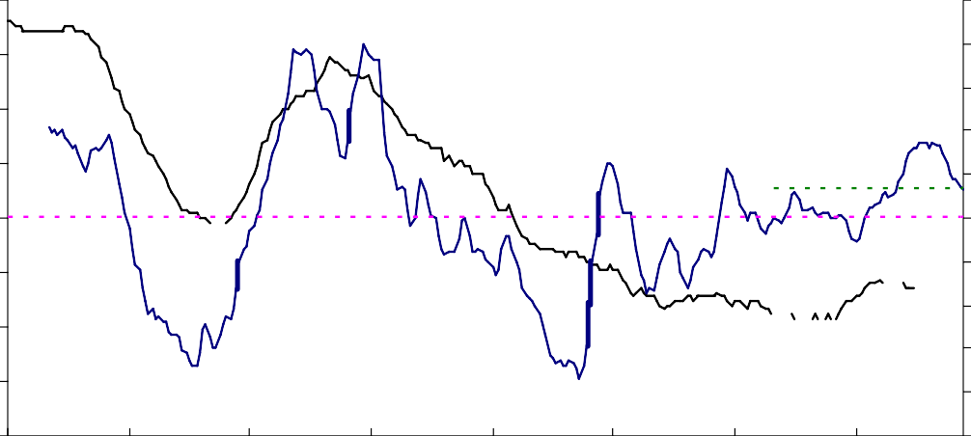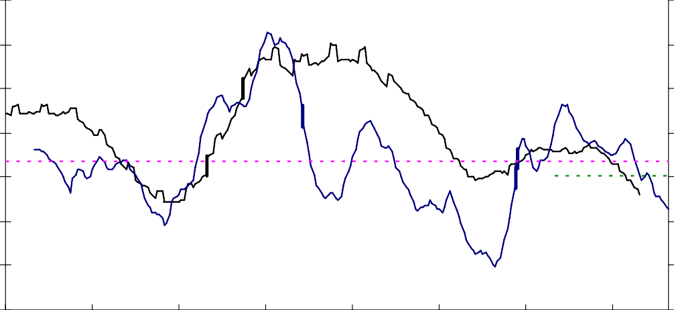

2006

2003

2000

1997

1994

1991

1988

20

18

16

14

12

10

8

6

4

2

0

--- 1985-2007 average

--- 2004-2007 average

Unemployment

rate (rhs)

Survey average (lhs)

**(3 month average - advanced 12 months)**

60

50

40

30

20

10

0

-10

-20

-30

-40

1985

Balance **Ireland - Unemployment expectations over the next 12 months** Per cent

|  |  |
| --- | --- |
| Chart 7: The change in low skill wage  inflation |  |
| Change in the annual rate of wage inflation of the  least skilled, pp 7 WM Ea 6 Wa  SE 5  Lon 4 Sc  3 NE  2  1 NW  0  -10 -5 -1 0 5  EM -2  -3 SW  -4  Change in the share of A8 immigrants 2004 to 2005, pp |  |

# References

Blanchflower, D.G. (1991), 'Fear, unemployment and pay flexibility', Economic Journal, March, pp. 483-496.

Blanchflower, D.G., and C. Shadforth (2007a), 'Entrepreneurship in the UK', Foundations and Trends in Entrepreneurship, 3(4), pp. pp 257-364.

Blanchflower, D.G. and C. Shadforth (2007b), ‘Fear, unemployment and migration’, NBER Working Paper 13506.

Jean, S. and M. Jiménez (2007), 'The unemployment impact of immigration in OECD countries', Economics epartment Working Paper #563, OECD, Paris.

OECD (2006), Economic Outlook, 80, November, Paris.